# Topic: Support Vector Machines (SVM)

1. **Business Problem**
   1. **What is the business objective?**
   2. **Are there any constraints?**
2. **Work on each feature of the dataset to create a data dictionary as displayed in the below image:**

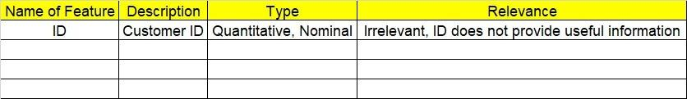

**2.1 Make a table as shown above and provide information about the features such as its data type and its relevance to the model building. And if not relevant, provide reasons and a description of the feature.**

**3.Data Pre-processing**

**3.1 Data Cleaning, Feature Engineering, etc.**

**3.2 Outlier Treatment.**

**4. Exploratory Data Analysis (EDA):**

**4.1 Summary.**

**4.2 Univariate analysis.**

**4.3 Bivariate analysis.**

**5. Model Building**

* 1. **Build the model on the scaled data (try multiple options)**
  2. **Use the SVM algorithm.**
  3. **Train and test the model and compare accuracies by building a confusion matrix and use different hyperparameters.**
  4. **Briefly explain the model output in the documentation.**

**6. Write about the benefits/impact of the solution - in what way does the business (client) benefit from the solution provided?**

**Problem Statement: -**

A construction firm wants to develop a suburban locality with new infrastructure but they might incur losses if they cannot sell the properties. To overcome this, they consult an analytics firm to get insights on how densely the area is populated and the income levels of residents. Use the Support Vector Machines algorithm on the given dataset and draw out insights and also comment on the viability of investing in that area.

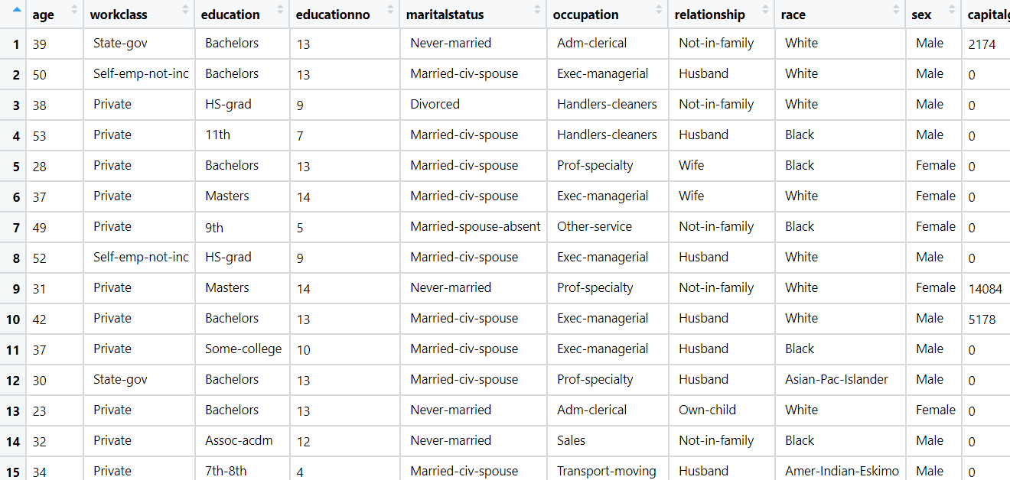

**Problem Statement: -**

In California, annual forest fires can cause huge loss of wildlife, human life, and can cost billions of dollars in property damage. Local officials would like to predict the size of the burnt area in forest fires annually so that they can be better prepared in future calamities.

Build a Support Vector Machines algorithm on the dataset and share your insights on it in the documentation. 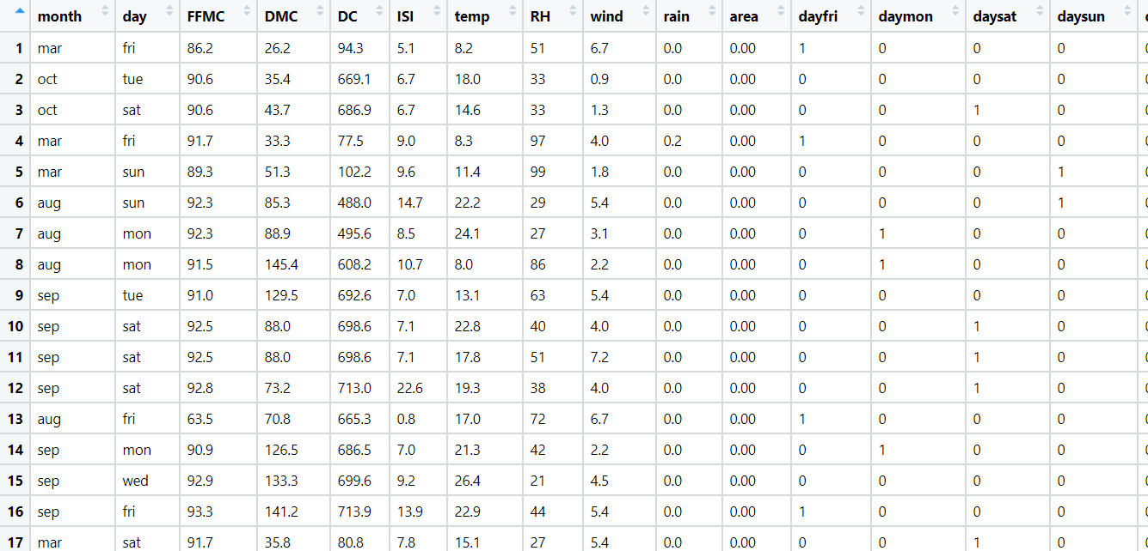

Note: - Size_ category is the output variable.